INFORMANT:

NAME :

AGE :

SEX :

EDUCATION:

OCCUPATION:

RESIDENCE :

RELIGION:

T/D:

CHIEF COMPLAINTS: CHRONLOGICAL ORDER

- Inability to use rt upper limb & lower limb
- Maximum chief complaints 3 only

According to systems

- Higher intellectual functions
  - Unconsciousness
  - Altered consciousness
  - Delirium
  - Photophobia
  - Behavioural abnormality
  - Speech
- Cranial N.
  - Abnormal sensation of smell - I
  - visual abnormality - II
  - double vision, squint - III,IV,VI
  - difficulty in mastication, loss of sensation over face V
  - deviation of angle of mouth, drooling of saliva VII
  - loss of taste sensation
  - vertigo, tinnitus, deafness VIII
  - nasal regurgitation & twang IX,X
  - recurrent choking episodes ,hoarseness of voice X
  - dysphagia “
  - drooping of shoulders
  - wasting of tongue, dysarthria XII

- Motor
  - Inability/unable to use limbs[weakness of limbs , Loss of power]
          - Proximal or distal
  - Wasting
  - Fasciculations
  - Abnormal movements[TREMORS,CHOREA,ATHETOSIS]
  - Pain in muscles
- Sensory
  - Loss of sensation – anesthesia
  - Tingling ,numbness – parasthesia
  - Hypoesthesia
  - Hyperesthesia
  - Root pain

- ↑ICT
  - Headache
  - Vomiting
  - Blurred vision
  - Neck stiffness
  - Convulsions

- Cerebellum
  - Swaying while walking
  - Unsteady gait
  - Inability to shave
Take food – incoordination

- ANS
  - Bladder fullness, precipitancy, hesitancy, urgency
  - Incontinence
  - Diarrhea/constipation
  - Abnormal sweating

- Misc
  - Fever
  - Fall
  - Seizure
  - Psychological changes
  - Bleeding tendency

H/O OF PRESENT ILLNESS :

OF COMPLAINT IN ORDER

1STCOMPLAINT : SWELLING

  - SITE where did he first notice
    - FROM
      - BURN
      - SCAR
      - PIN PRICK

    - NAEAVS
PT DEVELOPED WEAKNESS IN RT UL,LL ASSOCIATED WITH ANGLE DEVIATION.UNIFORM ,CONSCIOUS DURING THE EPISODE, PROGRESSION – INITIALLY COMPLETE LOSS ..NOW HE IS ABLE TO MOVE ,LOS OF SPEECH,

  - O WHEN DID U NOTICE cf APPEAR
    - GRADUAL - neoplastic – ACUTE IF SUDDEN HAEMORRHAGE INTO IT
Degenerating
infective
    - SUDDEN - vascular & now we need to rule out ALSO DEMYELINATING,TRAUMATIC
      - ISCHEMIC [if small-conscious at attack, if large-severe frontal head ache(↑ ICT)]or
      - HAEMORRHAGIC [ask for unconsciousness
semiconscious
irritable [most of times these will be present]

[after trauma]

IF ISCHEMIC RULE OUT Sx of ↑ ICT Signs
            - THROMBOSIS OR early morning projectile vomitings
            - EMBOLISM frontal headache
BY [SEE PROGRESSION] blurring of vision papilledema
± convulsions bradycardia
± hypotension
  - D last 2 `.` vagal inhibition
    - α PAINLESSNESS
      - SHORT=INFLAMMATORY [PAIN]
      - A BIT LONG=MALGNANT [NO PAIN]
      - LONG=CHR.INFLAMMATION[LESS PAIN]
      - LONG=BENIGN [NO PAIN]
  - P
    - PROGRESSIVE tell about motor, sensory Sx progression
      - VERY RAPID HAEMORRAGIC INFLAMMATORY
      - RAPIDLY MALIGNANT
      - SLOWLY BENIGN

    - REGRESSIVE EMBOLISM - TIA[24HRS]
- RIND[3 WKS]

inflammatory

    - STATIC

    - STATIC→RAPID [benign → malignant]

  - A/R

  - ASSOCIATED Sx APHASIA CORTEX
CONVULSIONS “
CONSCIOUSNESS
BLADDER ,BOWEL INCONTINENCE[medial side of cortex – ACA]

NOW ASK FOOR SOURCES OF EMBOLI
RECENT CHEST PAIN[MI]→Cx VT,VF,AF,ANEURYSM OF LV
[ASSOCIATED NAUSEA ,VOMITING]
h/o rheumatic prophylaxis

OR CAUSESOF THROMBOSIS

& OTHER CAUSES OF STROKE

TRAUMATIC TRIVIAL [UNNOTICED]TRAUMA IN OLD [ATHEROSCLEROSIS]→ CHR.SUB DURAL HEMATOMA
COUNTER COUP INJURY – `.`CEREBRAL ATROPHY

INFECTIVE RULE OUT INFECTIONS
ABSCESSES – USUALLY ASx
Rarely fits ask
- Ear ache temporal, cerebellar
- Recurrent [acute] sinusitis frontal
    - Order of sinuses
      - S
      - E
      - F
      - M
- Acute mastoiditis through
        - Emissary
        - Transverse sinus
- Infections of dangerous area of face
- “ of upper eye lid
- Orbital cellulitis
- TOOTH EXTRACTION
Septic foci in young pt
- Peritonsillar abscess carotid sheath→internal
Juglar→brain
Common cause of stroke in Children
- Pencil in mouth →internal carotid injury →thrombus→emboli
- Moyamoya disease
Signs
- Papilledema on that side
- Mild focal weakness

CHR. INFCTIONS
TB→ tuberculoma[CONTACT,CHR.COUGH,LONG DURATION Rx, Colour of urine]

RULE OUT DEMYELLENATING DISORDERS
RECENT VACCINATIONS – DOG /ANIMAL BITE
CHILD HOOD VIRAL INFECTIONS → SSPE
      - MEASLES
      - MUMPS
ACUTE DEMYELINATION - KURU
RABIES
LIVE VACCINE - ACTIVATION OF VIRUS
DEAD “ - AUTOIMMUNE

MULTIPLE SCLEROSIS - remissions & relapses
RULE OUT SOLS
ACUTE HEMATOMAS - never in life headache, trauma
ANEURYSM[YOUNG] berry is common
I`TUMORS - in children
2` - breast, lung
No h/o suggestive of csf rhinorrhea
Csf otorrhea
Bleeding from ear

No h/o fits

Head nodding

FEVER
Pt concentrates on pain ask for other Sx

    - PAIN
    - FEVER
    - DIFFICULTY IN RESPIRATION
    - DIFICULTY IN SWALLOWING
    - INTERFERING WITH MOVEMENT
    - DISFIGUREMENT
    - OTHER SWELLINGS
NF
DIAPHYSEAL ACLASIS
HODGKIN
    - SECONDARY CHANGES
          - SOFTENING
          - ULCERATION
          - FUNGATION
          - INFLAMMATION

    - IMPAIRMENT OF FUNCTION [osteosarcoma →in/complete loss of knee movement
Cold abscess→ “ “ spine movement ]

            - NATURE OF MOVEMENT
            - DEGREE

    - RECURRENCE after excision
            - Benign→malignant
            - Malignant
            - Cyst recur if wall incompletely removed

            - Eg :
              - Paget’s recurrent fibroid
              - Hydrocele if sac not removed completely

    - LOSS OF BODY WT
          - TB + SWELLING
          - COLD ABCESS +TB
          - MALIGNANCY
          - AIDS

h/oTIA,RIND

2NDCOMPLAINT : Fits

      - Before
      - During
      - After

SUMMARY : ANATOMICAL Δ – LT CORTEX – ACA TERRITORY
PATHOOGICAL – VASCULAR – THROMBOSIS/ EMBOLISM/ HAEMORRHAGE

H/O OF PAST ILLNESS :
            - Similar complaints
            - PATIENT IS A KNOWN Hypertensive
            - PATIENT IS NOT A KNOWN Diabetic
            - PATIENT IS NOT A KNOWN epileptic
            - No h/o hyperlipidemia
            - smoking
            - MI
            - TIA,RIND
            - No h/o suggestive of asthma
            - h/o suggestive of bleeding disorders
            - TB [CHRONIC COUGH]
            - SYPHILIS[NEURO MAY OCCUR]

PAST SURGICAL H/O :

- APPENDICECTOMY → ILLIOINGUINAL N.→
- HERNIA → INCISIONAL HERNIA
- SPLENECTOMY → Hb [not Hbs]

TREATMRNT H/O:
FOR PRESENT COMPLAINT

DRUG H/O: NALIDIXIC ACID –
INH – B6 DEFICIENCY PERIPHERAL NEUROPATHY
PHENYTOIN – ATAXIA,NYSTAGMUS

MENSTRUAL H/O

MARITAL STATUS :

CHILDREN :

PERSONAL H/O:
- APPITITE:
- DIET
- DIGESTION
- BLADDER
- BOWELS
- SLEEP DISTURBANCES
- HABITS :
  - SMOKING
            - Giant cell arteritis
            - CHUTTA CANCER = of hard palate reverse cigar smoking
  - TOBACCO CHEWING
            - KHAINI CANCER = LIME + tobacco in gingivolabial sulcus
  - PAN
  - ALCHOHOL
  - SWIMMING

FAMILY H/O : DEATH ,WHY, HOW ?

- SIMILAR COMPLAINTS
- DM
- HTN
- Familial hyperlipidemia
- TB
- ASTHMA
- BLLEEDING DISORDERS

OCCUPATIONAL H/O:

TRAVEL H/O:

GENERAL EXAMINATION :
- CONSCIOUS
- COHERENT
- COOPERATIVE
- COMFORTABLY

- HT
- WT
- BM I
- GAIT
- BUILT [SKL. FRAM WORK]
- NOURISHED [OBO
                - MUSCLE MASS
                - SKIN FOLD THICKMESS]
- ATTIITUDE [Osteosarcoma on nerve
Fracture
dislocation]

- PALLOR
- ICTERUS
- CYANOSIS
- CLUBBING
- KYPHOSIS
- SCOLIOSIS
- KOILONYCHIA
- GENERALISED LYMPHEADENOPATHY
- PEDAL EDEMA
- HAIR
- SKIN
- EYE BROWS
- FROWNING
- EYES
- PAROTID
- NECK SWELLING
- DROOLING OF SALIVA
- NAILS
- DROOPING OF SHOULDER
- BREAST/GYNECOMASTIA
- OBVIOUS SWELLINGS
- GENETALIA[HERNIA,HYDROCELE]

NEUROCUTANEOUS MARKERS
      - ash-leaf spot –TSC
      - TSC - SHAHGREEN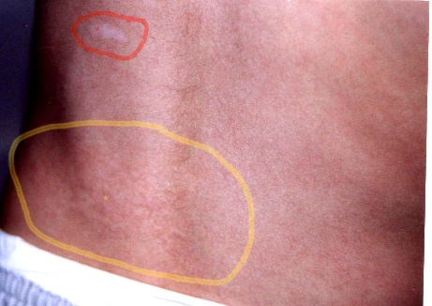
      - CAFÉ AU LEIT SPOTS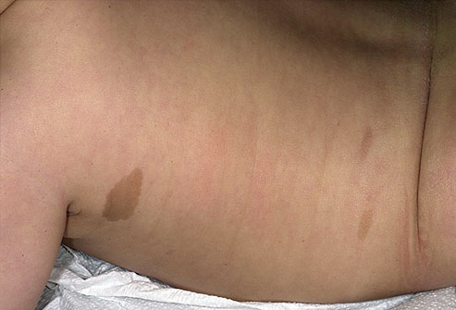
      - NEUROFIBROMAS
      - PORT WINE STAIN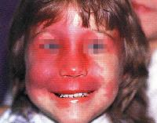 STURG
      - ACNE – ADENOMA SEBACEAUM - TSC

VITALS :
- TEMPERATURE : [↑ in inflammatory swelling]
- PULSE : [↑in inflammatory swelling]
- B.P
- R.R
- SPO₂:

SYSTEMIC EXAMINATION:

MMSE
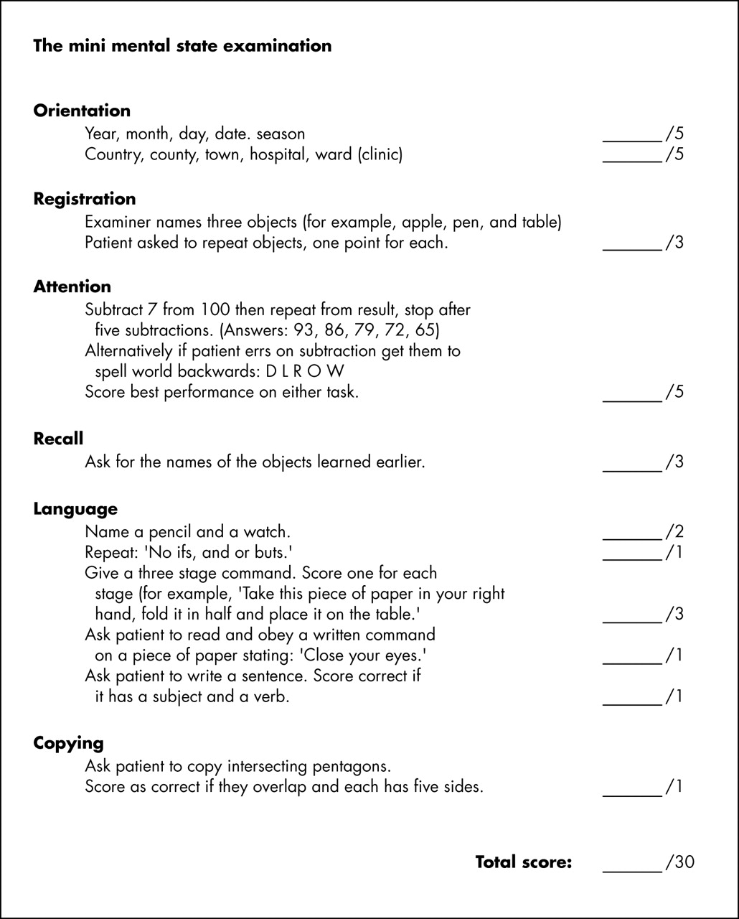

- HIGHER INTELLECTUAL FUNCTIONS -CHMOS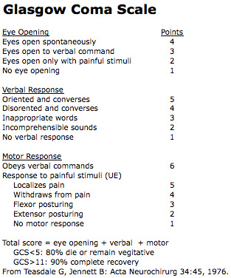
  - LEVEL OF CONSCIOUSNESS - GCS
  - HANDEDNESS
  - MEMORY
    - Recent
    - past
  - orientation
    - time
    - place
    - person
  - speech
    - dysarthria[7,9,10,12]
    - aphasia
  - general intelligence
  - delusions[false belief],hallucinations[false perception],illusions[false interpretations],
  - primitive reflexes

CNs

      - vestibule cochlear nerve
        - vestibular
          - caloric stimulation test
37+/- 7 c
COWS – nystagmus – side of nystagmus is the side of rapid component
        - cochlear
          - Rinne’s
          - weber’s
      - G9
        - MOVEMENT OF SOFT PALATE[ SAY “AAAH”]
        - PHARAYENGEAL/GAG REFLEX
        - POST. 1/3 RD OF TONGUE

MOTOR SYSTEM

REFLEXES
- 0 = no response; always abnormal
- 1+ = a slight but definitely present response; may or may not be normal
- 2+ = a brisk response; normal
- 3+ = a very brisk response; may or may not be normal
- 4+ = a tap elicits a repeating reflex (clonus); always abnormal

Sensory System

AUSCULATE CAROTID BRUIT

D0IAGNOSIS :
- ANATOMICAL
- ETIOLOGICAL
- PATHOLOGICAL
- CLINICAL

INVESTIGATIONS :
TO CONFIRM Δ

TREATMENT :
FOR THIS PATIENT

